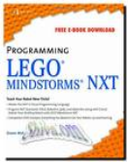
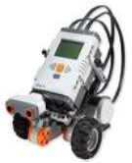
Has successfully demonstrated the engineering and programming activities necessary to have their robot “Move Straight”
This to Certify that the Engineering Team

